**The Belicamp*The Words of Archangel Michael**

**It is his time**

**No one can stop him**

**The Belicamp-The Belicamp-The Belicamp**

**I smell death**

**And so it is, for this is your destiny**

**This sign is given**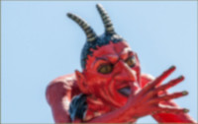

**As it is for this land**

**So it is for this world**

**The pieces are placed together**

**For the prophecy to begin**

**The terrible time is upon us**

**Woe to the inhabitant of this land**

**Woe to those who live in this world**

**There is no escape**

**God the Father has made his play**

**God has chosen his way**

**Mankind has found his end**

**Only the Prophecy of the Magician can deliver the few**

**He comes by the light and the sky**

**And it is so saith the Lord**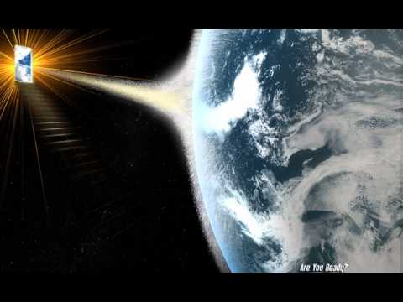

**Call on the Father, Call on the Angels**

**Your cries fall on death ears**

**For this is the land of the dead**

**And it is so saith the Lord**

**For a great death comes from the sky**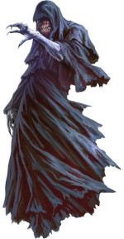

**The Belicamp, the Belicamp, the Belicamp**

**Pray for the Lord and the Magician**

**For the Belicamp encircles them**

**The Father has sent the Belicamp to stop them**

**The Belicamp is the Demon of the Father**

**We walk along the river**

**I walk ahead and encounter the Belicamp**

**He stoops close to the ground and eats**

**New life has sprung from the ground**

**I am no more than twelve feet away**

**He eats next to the river and pays me no mind**

**I hear the Hourglass is almost empty**